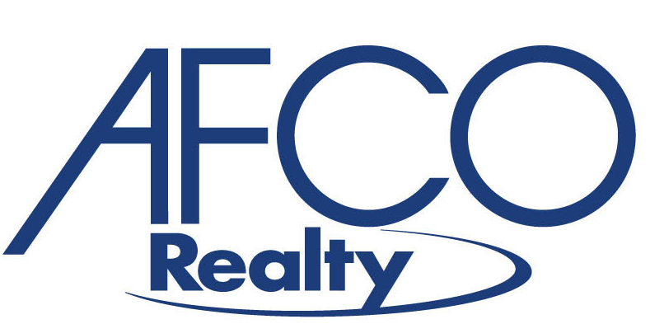


To: Friends and Family
Subject: Beat Lupus – ING Marathon / Half Marathon – March 25, 2007
Date: February 27, 2007

I am writing today to ask for your support of my Beat Lupus team in the inaugural ING Marathon /Half Marathon benefiting the Georgia Chapter of the Lupus Foundation of America. The goal for the event is to raise awareness to improve the lives of lupus patients. AFCO Realty, LLC is honored to be a corporate sponsor in support of my personal commitment to reach my goal of $10.000.

Lupus is a widespread and lifelong autoimmune disease that causes the immune system to attach the body’s own tissue and organs. Lupus often has severe lifelong and life threatening effects on women, men and children.

You can show your support of my commitment and my team to two ways:

- Come run with me by signing up at lfaga.org to run with us at the “ING Marathon / Half Marathon.”

- Donate to my team. There are two (2) ways to donate:
  - The simplest is to go to http://www.firstgiving.com/sfriedman-beatlupus where you can donate on a secure web site online and automatically receive a tax-deductible receipt for your donation.
  - Send a tax-deductible check payable to The Lupus Foundation of America, Georgia Chapter, Attn. Sam Friedman, 1800 Lake Park Drive, Suite 101, Smyrna, GA 30080.

I thank you for your interest and support of a mission that is so important to me and my family. If you have any questions, please call Gail Davis at 404.233.1700.

Thanks,

Sam

